Assignment #5 Written Report

**Source Code for Part I:**

GradeCalculator.java:

import javax.swing.*;

import java.awt.*;

import java.awt.event.*;

import java.text.NumberFormat;

/**

*This class creates a GUI to calculate a student's GPA

*Uses the JFrame class to create stand alone application

*@author Michael Roscoe

**/

public class GradeCalculator extends JFrame implements ActionListener {

//Delcaring instance variables

private JLabel gradeLabel;

private JLabel creditLabel;

private JTextField gradeField;

private JTextField creditField;

private JButton addGPA;

private JButton clearGPA;

private JLabel messageLabel;

private JLabel gradeMessage;

private double creditHours;

private double currentPoints;

public GradeCalculator () {

setSize (280, 250);

//Default values

creditHours = 0.0;

currentPoints = 0.0;

//Creation of labels, buttons, fields, actionlisteners

gradeLabel = new JLabel("Course Letter Grade:");

creditLabel = new JLabel("Course Credit Hours:");

gradeField = new JTextField(2);

creditField = new JTextField(2);

addGPA = new JButton("Add to GPA");

clearGPA = new JButton("Clear GPA");

addGPA.addActionListener(this);

clearGPA.addActionListener(this);

messageLabel = new JLabel("Welcome to my GPA calculator!");

gradeMessage = new JLabel("Enter your first grade & credit hours.");

//Filling of the container

Container contentPane = getContentPane();

contentPane.setLayout(new FlowLayout());

contentPane.add(gradeLabel);

contentPane.add(gradeField);

contentPane.add(creditLabel);

contentPane.add(creditField);

contentPane.add(addGPA);

contentPane.add(clearGPA);

contentPane.add(messageLabel);

contentPane.add(gradeMessage);

setDefaultCloseOperation (JFrame.EXIT_ON_CLOSE);

}

public void actionPerformed(ActionEvent e) {

NumberFormat formatter = NumberFormat.getInstance();

formatter.setMaximumFractionDigits(1);

formatter.setMinimumFractionDigits(1);

double cumulativeGrade = 0;

if (e.getSource() == addGPA) {

String grade = gradeField.getText().toUpperCase();

String gradeIn;

switch (grade) {

case "A+": gradeIn = "4.3"; break;

case "A": gradeIn = "4.0"; break;

case "A-": gradeIn = "3.7"; break;

case "B+": gradeIn = "3.3"; break;

case "B": gradeIn = "3.0"; break;

case "B-": gradeIn = "2.7"; break;

case "C+": gradeIn = "2.3"; break;

case "C": gradeIn = "2.0"; break;

case "D": gradeIn = "1.0"; break;

case "F": gradeIn = "0.0"; break;

case "WF": gradeIn = "0.0"; break;

default: gradeIn = "Invalid";

}

if (gradeIn.equals("Invalid")) {

messageLabel.setText("Invalid Grade - GPA not Changed");

} else {

double gradeNumber = Double.parseDouble(gradeIn);

double courseHours = Double.parseDouble(creditField.getText());

currentPoints += gradeNumber * courseHours;

creditHours += courseHours;

cumulativeGrade = currentPoints / creditHours;

messageLabel.setText("Points for this course: " + formatter.format(gradeNumber * courseHours));

}

gradeMessage.setText("Your cumulative GPA is: " + formatter.format(cumulativeGrade));

} else {

currentPoints = 0.0;

creditHours = 0.0;

cumulativeGrade = 0.0;

messageLabel.setText("Totals have been reset.");

gradeMessage.setText("Enter your first grade & credit hours.");

}

gradeField.setText("");

creditField.setText("");

}

public static void main(String[] args) {

new GradeCalculator().setVisible(true);

}

}

**Sample Output For Part 1:**

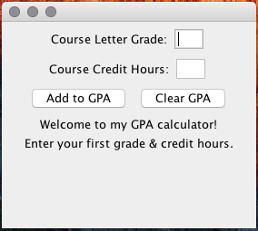

Welcome Screen

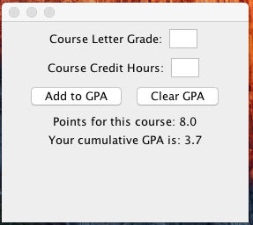

John Doe’s Information

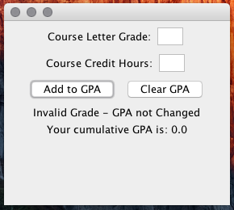

Invalid Grade Entry

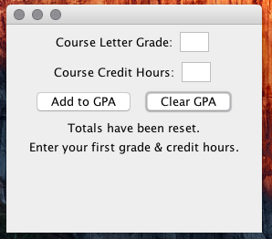

Reset Button Pressed

Source Code for Part 2:

ProductButton.java:

import java.awt.*;

import javax.swing.*;

import java.text.NumberFormat;

/**

*A ProductButton is a special kind of JButton,

*used to display products for sale.

*@author Natalie Webber

*@author Michael Roscoe

*/

public class ProductButton extends JButton {

/**

*The name of the product.

*/

private String productName;

/**

*The price for which we will sell the product

*/

private double productPrice;

/**

*Creates a button that will display an image of the product

*(assumed to be stored in a file starting with the specified

*name and ending with ".jpg"), the specified product name,

*and the specified price (formatted properly); the text is

*displayed below the image and is centered.

*@param name The product name.

*@param price The selling price for this product.

*/

public ProductButton (String name, double price) {

super(name);

ImageIcon buttonIcon = new ImageIcon(name + ".jpg");

NumberFormat formatter = NumberFormat.getCurrencyInstance();

super.setText(name + ": " + formatter.format(price));

super.setIcon(buttonIcon);

this.setVerticalTextPosition(AbstractButton.BOTTOM);

this.setHorizontalTextPosition(AbstractButton.CENTER);

productName = name;

productPrice = price;

}

/**

*Retrieves the product name.

*@return The product name.

*/

public String getName() {

return productName;

}

/**

*Retrieves the selling price.

*@return The price for which we will sell the product.

*/

public double getPrice() {

return productPrice;

}

}

CinemaFrame.java:

import javax.swing.*;

import java.awt.*;

import java.awt.event.*;

import java.text.NumberFormat;

/**

*This class creates a simulation of a movie theatre cash register

*Uses the JFrame class for creation as a stand alone application

*@author Michael Roscoe

**/

public class CinemaFrame extends JFrame implements ActionListener {

private JLabel topLabel, couponLabel, totalLabel;

private ProductButton adultTicket, childTicket, seniorTicket, popcorn, candy, pop;

private JButton redeem, nextCustomer;

private JTextField coupon;

private double runningTotal;

public CinemaFrame () {

super ("Cinema Register");

setSize(600,400);

runningTotal = 0;

//Creation of labels, buttons, fields, actionlisteners

topLabel = new JLabel("Click on the products that the customer wishes to purchase:");

couponLabel = new JLabel("Coupon: $");

totalLabel = new JLabel("Current Total: $0.00");

adultTicket = new ProductButton("Adult Ticket", 12.50);

childTicket = new ProductButton("Child Ticket", 6.25);

seniorTicket = new ProductButton("Senior Ticket", 8.75);

popcorn = new ProductButton("Popcorn", 5.50);

candy = new ProductButton("Candy", 3.25);

pop = new ProductButton("Pop", 2.75);

redeem = new JButton("Redeem");

nextCustomer = new JButton("Next Customer");

coupon = new JTextField(4);

//Creation of the listeners

adultTicket.addActionListener(this);

childTicket.addActionListener(this);

seniorTicket.addActionListener(this);

popcorn.addActionListener(this);

candy.addActionListener(this);

pop.addActionListener(this);

redeem.addActionListener(this);

nextCustomer.addActionListener(this);

//Creation of top panel

JPanel topPanel = new JPanel();

topPanel.add(topLabel);

//Creation of the center panel

JPanel centerPanel = new JPanel();

centerPanel.setLayout(new GridLayout(2,3));

centerPanel.add(adultTicket);

centerPanel.add(childTicket);

centerPanel.add(seniorTicket);

centerPanel.add(popcorn);

centerPanel.add(pop);

centerPanel.add(candy);

//Creation of the bottom panel

JPanel bottomPanel = new JPanel();

bottomPanel.add(couponLabel);

bottomPanel.add(coupon);

bottomPanel.add(redeem);

bottomPanel.add(totalLabel);

bottomPanel.add(nextCustomer);

//Creation of the full window

Container contentPane = getContentPane();

contentPane.add(topPanel, BorderLayout.PAGE_START);

contentPane.add(centerPanel, BorderLayout.CENTER);

contentPane.add(bottomPanel, BorderLayout.PAGE_END);

setDefaultCloseOperation(JFrame.EXIT_ON_CLOSE);

}

public void actionPerformed(ActionEvent e) {

NumberFormat formatter = NumberFormat.getCurrencyInstance();

if (e.getSource() == nextCustomer) {

runningTotal = 0;

totalLabel.setText("Current Total: " + formatter.format(runningTotal));

} else if (e.getSource() == redeem) {

double couponAmount = Double.parseDouble(coupon.getText());

runningTotal -= couponAmount;

totalLabel.setText("Current Total: " + formatter.format(runningTotal));

coupon.setText("");

} else {

ProductButton temp = (ProductButton)(e.getSource());

runningTotal += temp.getPrice();

totalLabel.setText("Current Total: " + formatter.format(runningTotal));

}

}

public static void main(String[] args) {

new CinemaFrame().setVisible(true);

}

}

**Sample Output from Part 2:**

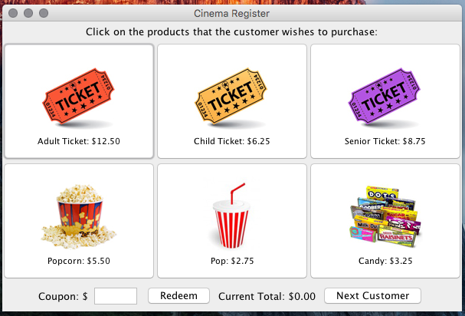

First Opened, no buttons pressed

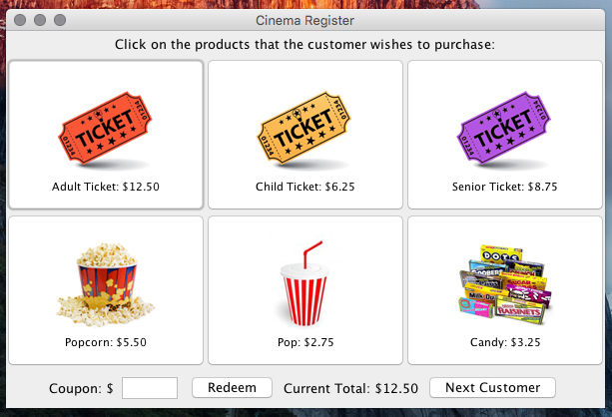Adult Ticket Pressed Once

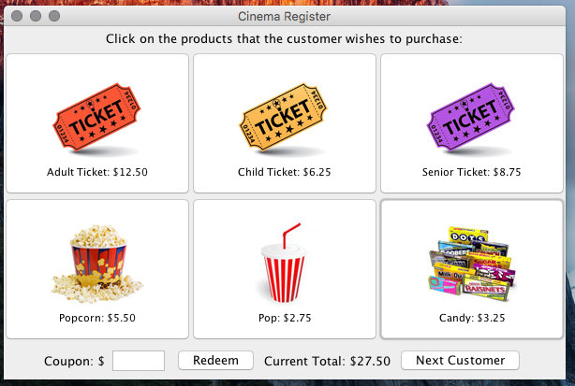

Addition of Child ticket, candy, and 2 pops

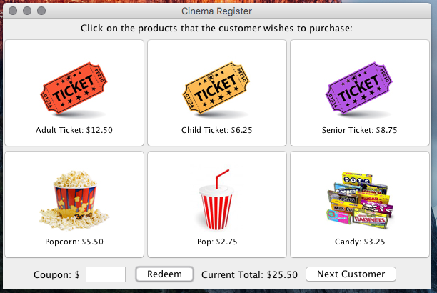Subtraction of a $2.00 coupon

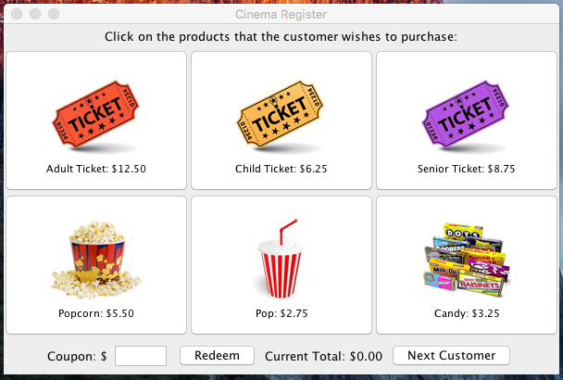

Next Customer Button Pressed